ESS QTP Automation Framework

Document Control
Process | Name | Title | Date
Authored by | Webber Ling | Team Lead, Quality Assurance | May 18, 2011
Approved by

Revision History
Date | Version | Description | Author
May 18, 2011 | 1.0 | Initial version | Webber Ling

ESS QTP Automation Framework
Table of Contents

1. INTRODUCTION - 3 -
1.1 ESS QTP AUTOMATION FRAMEWORK - 3 -
2. REFERENCE - 3 -
3. PURPOSE - 3 -
3.1 PURPOSE OF ESS QTP AUTOMATION FRAMEWORK - 3 -
4. ESS QTP AUTOMATION FRAMEWORK - FOLDER STRUCTURE - 3 -
4.1 DESCRIPTION - 3 -
4.2 ESS QTP automation FRAMEWORK - FOLDER STRUCTURE - 4 -
5. ESS QTP AUTOMATION FRAMEWORK – MULTI FUNCTION LIBRARY LAYER - 5 -
5.1 DESCRIPTION - 5 -
5.2 MULTIPLE FUNCTION LIBRARY LAYER - 5 -
6. ESS QTP AUTOMATION FRAMEWORK – TESTING DATA MANAGEMENT - 7 -
6.1 DESCRIPTION - 7 -
6.2 TEST DATA - 7 -
6.3 REPORTS - 7 -
6.4 SCREEN CAPTURE - 7 -
7. ESS QTP AUTOMATION FRAMEWORK – QC INTEGRATION - 8 -
7.1 DESCRIPTION - 8 -
7.2 QC INTEGRATION STRUCTURE - 8 -
8. ESS QTP AUTOMATION FRAMEWORK – WORK FLOW - 8 -
8.1 DESCRIPTION - 8 -
8.2 ESS QTP AUTOMATION FRAMEWORK WORKFLOW - 9 -

ESS QTP Automation Framework

INTRODUCTION

ESS QTP AUTOMATION FRAMEWORK
This document outlines the ESS QTP Automation Framework along with QC integration as a plus, which accommodates all AUTs (Application Under Test), BS/CS structure, or different technology, e.g. .Net, Web, VB, Java, C++, etc, which will be used by ESS QA team.
The framework structure defined in this document should be strictly followed because its internal function layer modulizes and optimizes the complex QTP codes implementation for various standard objects. It cuts down the automation engineer training cost, script developing efforts and maintenance cost as well. And it allows easy expanding for integration testing.

REFERENCE
<ESS QTP Coding Standard - PopVerifyFunction.doc>
<ESS QTP Coding Standard - ObjectRepositoryManagement.doc>
<ESS QTP Coding Standard - BestPractice.doc>

PURPOSE

PURPOSE of ESS QTP AUTOMATION FRAMEWORK
The purpose of this document is to introduce the ESS QTP automation framework which categorized as below:
- ESS QTP Automation Framework – Folder Structure
- ESS QTP Automation Framework – Multiple Function Library Layer
- ESS QTP Automation Framework – Testing Data Management
- ESS QTP Automation Framework – QC Integration
- ESS QTP Automation Framework – Work Flow

ESS QTP Automation Framework - folder structure

description
Automation folder structure defines the physical folder structure for categorizing all testing related data. The folder structure is defined as Generic structure. All scripts, function libraries, documents, log files, object repository, screen captures should be placed under corresponding directory.

ESS QTP automation Framework - folder structure
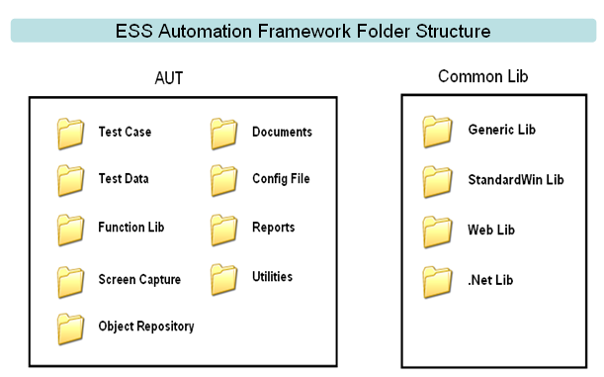

AUT | Test Case | Test Case directory should be placed under the AUT (Application Under Test) folder and all the test scripts should be placed in this directory with the naming conventions.
AUT | Test Data | Data sheets for all scenarios and individual script should be placed under this directory with the naming conventions.
AUT | Function Lib | All user-defined, product-specific function libraries should be placed under this directory. Basically, two libraries for each AUT:  <AUTName>_FunctionLib_Init.vbs  <AUTName>_FunctionLib_Main.vbs
AUT | Screen Capture | All runtime screen captures recorded in test scripts should be stored in this directory, which will be used for post-execution reference and results analyse if necessary.
AUT | Object Repository | All AUT related GUI objects should be placed here as shared object repository, which is used by all test script under Test Case directory. It can be just one .tsr file which contains all AUT GUI objects or multiple .tsr file which categorized by various modules or components for easy maintenance.
AUT | Documents | All testing configuration, execution, results analysing related instruction documents should be stored under this directory, e.g. script user guide, AUT configuration guide
AUT | Config File | This is where QTP configuration script stores, by executing the Config script, the pre-defined QTP runtime settings will be automatically applied to the testing pc for testing execution, and the QTP Object Identification setting will be applied for script developing as well. It is very important to execute the Config script before developing and executing any test. However this is one-time configuration, which means one specific testing machine only needs to execute the Config script once at the very beginning as long as nobody manually change the QTP settings.
AUT | Reports | This directory contains all testing related report file, log file, etc, during the testing execution.
AUT | Utilities | All third-Party testing tools or self-developed tools used to assist QTP automated testing should be placed under this directory.

Common Lib | Generic Lib | LibraryFile_Generic.vbs (read-only)  User defined generic functions, e.g. file system I/O functions, Excel read/write functions, string manipulate functions, etc
Common Lib | StandardWin Lib | LibraryFile_StandardWindows.vbs (read-only)  User defined functions for Microsoft Windows standard window objects
Common Lib | Web Lib | LibraryFile_Web.vbs (read-only)  User defined functions for Web objects
Common Lib | .Net Lib | LibraryFile_NET.vbs (read-only)  User defined functions for .Net objects

ESS QTP Automation Framework – MULTIPLE FUNCTION LIBRARY LAYER

DESCRIPTION
The test automation toolset needs to be treated like software development architecture, with reusable modules that exist as part of standard automation frame work.
The multiple function library layer modulizes the basic functions for standard windows controls, standard .Net controls and standard Web controls and object-independent function library. And the AUT specific library layer is listed as well.

MULTIPLE FUNCTION LIBRARY LAYER
There are two categories of function libraries: one is common function library which stores function libraries shared by all AUTs (under Common Lib folder). Another is AUT specific library which applies to one and only one specific AUT (under AUT folder).
These two categories are defined by the Automation Folder Structure, which is called Physical Category.
The function library layer here is defined by function call logic, which is called Logic Category.
There are three layers (Logic Category) of function libraries which are defined in this framework.

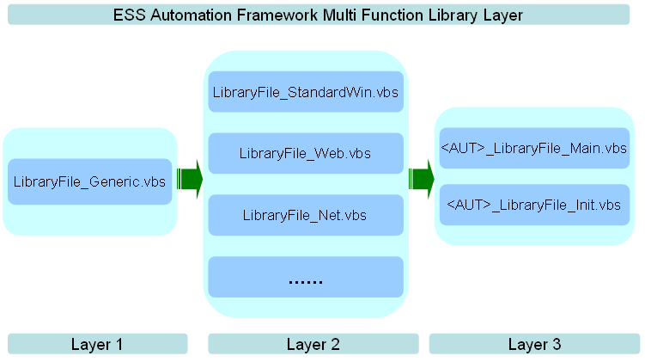

There are three layers of function library. The later one depends on previous one, e.g. Layer 3 depends on Layer 2 which depends on Layer 1.
Layer 1:
This is an independent function layer, in another word, it is NOT object-related.
And it is the lowest layer which can be called by any other function library and can be used by any type of AUT.
For example, file I/O functions, Excel manipulate functions, string compare functions, etc.
Layer 2:
This layer contains libraries for specific type of object, e.g. LibraryFile_Web.vbs defines the very basic methods/functions for Web app objects, for example, WebEdit, WebList, etc. And LibraryFile_StandardWin.vbs for standard windows objects, LibraryFile_Net.vbs for .Net objects. The functions/methods defined in this layer are registered for its own class, which means user can use context menu to browse and select the method during scripting in QTP.
Layer 3:
This layer is AUT specific function library, which means each AUT has its own init library and main library and it depends on its corresponding library in Layer 2, e.g. Retirement Studio is a .Net standard alone application, the user function defined in its corresponding main function library RetirementStudio_LibraryFile_Main.vbs will call methods defined in LibraryFile_Net.vbs.
For each AUT, there are two function libraries in Layer 3, one is <AUT>_LibraryFile_Init.vbs, which defines AUT specific const, QTP option settings, etc. Another is <AUT>_LibraryFile_Main.vbs, which defines all the user defined functions for the AUT.

ESS QTP Automation Framework – TESTING DATA MANAGEMENT

DESCRIPTION
Test data management in the document includes all testing related input/output and log data structure and naming convention.
Based on the Folder Structure, there are three directories used to store testing data: Test Case, Reports, Screen Capture.

TEST dATA
All test input data should be placed under Test Data folder under its AUT directory using the same name as its test script name. It could be MS Excel file type or TXT file format or any other type. For example, a test script named “RS_DataStandardCheck001”, which is placed under Test Case folder, and its corresponding input data should named as “RS_DataStandardCheck001.xls” and placed under Test Data folder.
A MS Excel file using the same name as the test script is required to store very basic testing info, e.g. Results (E_OK/E_ERROR), TimeStart, TimeEnd. This gives tester a brief idea of the testing result and the testing start and testing end time. Refer to below screenshot.
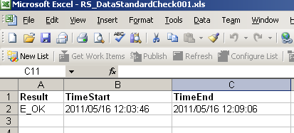
If one particular test script it requires multiple input data files, then a sub folder should be created under Test Data folder using the same name as its test script. All the testing input files should be placed under this sub folder.

REPORTS
All testing output data/log files should be placed under this folder. And the naming convention should be applied as well. (The output/log file should use the same name as test script and if multiple output files for single test script is required, need to create a sub folder under Reports folder using the same name as test script.)

SCREEN CAPTURE
This folder is used to store all runtime screen captures which will be used as reference when test requires further analyze.
As a standard of this framework, each AUT specific function will generate a runtime screen capture using the function name and it is stored in Screen Capture folder.
As a standard workflow of this framework, a monthly or bi-monthly backup of this folder is required to archive all screen captures for future reference.

ESS QTP Automation Framework – QC INTEGRATION

DESCRIPTION
As a test management tool, HP QC is well integrated with QTP. The automation test scripts, resources will be stored in QC Test Plan.
QC Test Lab supports automation batch execution functionality as well as scheduled runner. Automation test scripts should be executed from QC, which makes all execution results history available in QC.
Meanwhile QC auto-email notification feature will update the predefined users with the execution results as soon as it finishes execution.

QC INTEGRATION STRUCTURE
The below chart shows the generic QC structure for one specific AUT.
All items marked in dark blue are QC items which stores in QC database after user upload. For example, Test Scripts are stored in QC test plan, test set 20110304.1 is a user defined test set using build name and linked to related test scripts.
All items marked in light blue are external resources which are required to execute the test from QC. For example Web Lib, this equals to LibraryFile_Web.vbs, which stores under Common Lib directory and will be called in AUT main library and be used in Test scripts.
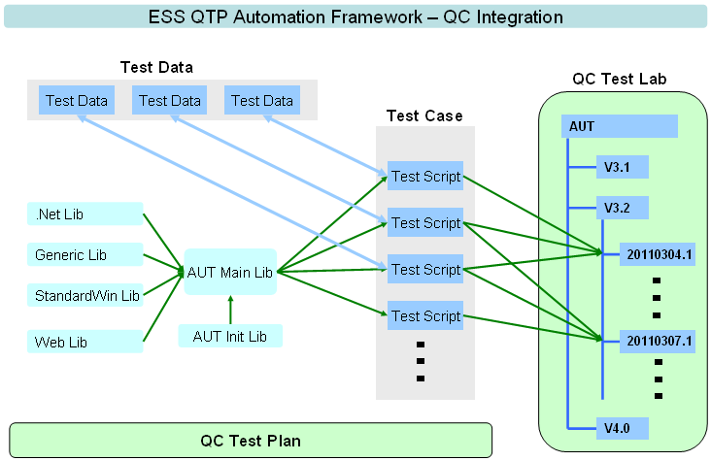

ESS QTP Automation Framework – WORK FLOW

DESCRIPTION
The workflow illustrates the relationship between different components/folders in this automation framework. Test script under Test Case folder will be the core of this workflow and rest of components will be directly or indirectly connected to Test Script.

ESS QTP AUTOMATION FRAMEWORK WORKFLOW
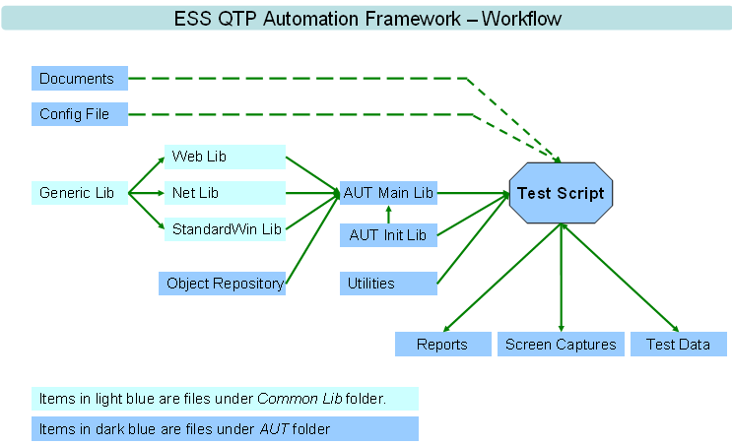
Documents and Config File affect Test Script indirectly (dash line) because they have no file or data will be called or used by Test Script. Refer to chapter 4.2 for detailed instruction on these two components.

